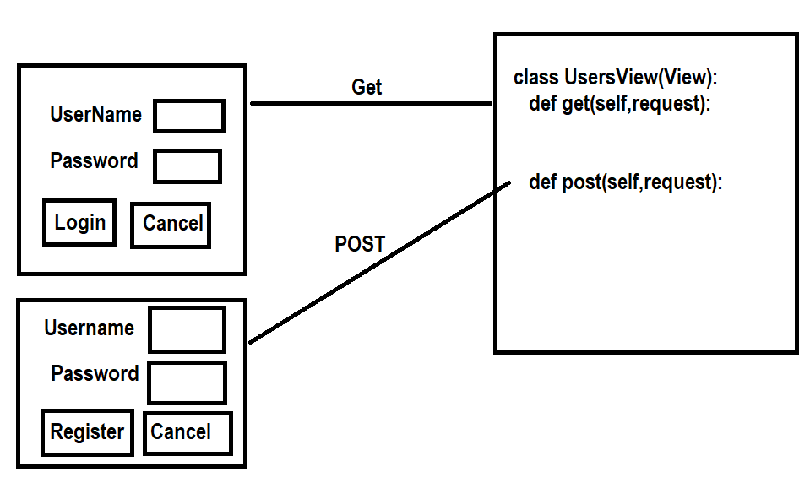
Views.py

from django.shortcuts import render
# Create your views here.
from django.views import View
from django.http import HttpResponse
users={}
class UsersView(View):
def get(self,request):
uname=request.GET.get('uname')
pwd=request.GET.get('pwd')
if uname in users and users[uname]==pwd:
response=HttpResponse("<h2>welcome</h2>")
return response
else:
response=render(request,"login.html",context={'msg':"invalid username or password"})
return response

def post(self,request):
uname=request.POST.get('uname')
pwd=request.POST.get('pwd')
if uname in users:
response=render(request,"register.html",context={'msg':"user with name exists"})
return response
else:
users[uname]=pwd
response=HttpResponse("User Registered")
return response

class LoginTempView(View):
def get(self,request):
response=render(request,"login.html")
return response

class RegisterTempView(View):
def get(self,request):
response=render(request,"register.html")
return response

register.html
<!DOCTYPE html>
<html lang="en">
<head>
<meta charset="UTF-8">
<meta name="viewport" content="width=device-width, initial-scale=1.0">
<title>Document</title>
</head>
<body>
<table border="2" width="70%">
<form action="/first/" method="post">
{%csrf_token%}
<tr>
<td>UserName</td>
<td><input type=text name="uname"></td>
</tr>
<tr>
<td>Password</td>
<td><input type="password" name="pwd"></td>
</tr>
<tr>
<td><input type="submit" value="register"></td>
<td><input type="reset" value="cancel"></td>
</tr>
</form>
</table>
{{msg}}
</body>
</html>

login.html
<!DOCTYPE html>
<html lang="en">
<head>
<meta charset="UTF-8">
<meta name="viewport" content="width=device-width, initial-scale=1.0">
<title>Document</title>
</head>
<body>
<table border="2" width="70%">
<form action="/first">
<tr>
<td>UserName</td>
<td><input type=text name="uname"></td>
</tr>
<tr>
<td>Password</td>
<td><input type="password" name="pwd"></td>
</tr>
<tr>
<td><input type="submit" value="login"></td>
<td><input type="reset" value="cancel"></td>
</tr>
</form>
</table>
{{msg}}
</body>
</html>

Urls.py
rom django.contrib import admin
from django.urls import path
from app.views import UsersView,LoginTempView,RegisterTempView
urlpatterns = [
path('admin/', admin.site.urls),
path('first/',UsersView.as_view()),
path('login/',LoginTempView.as_view()),
path('register/',RegisterTempView.as_view()),
]

Settings.py
INSTALLED_APPS = [
'django.contrib.admin',
'django.contrib.auth',
'django.contrib.contenttypes',
'django.contrib.sessions',
'django.contrib.messages',
'django.contrib.staticfiles',
'app'
]

TEMPLATES = [
{
'BACKEND': 'django.template.backends.django.DjangoTemplates',
'DIRS': [BASE_DIR/"templates"],
'APP_DIRS': True,

TemplateView

TemplateView is used for displaying template (html)
This can be static template or dynamic.
Django's TemplateView is a built-in generic class-based view used to render a specific template and return an HTTP response
It is the simplest class-based view, ideal for "About Us" or landing pages that do not require complex logic or form processing

Attributes of TemplateView
- template_name : name of template which has to rendered
- extra_context: This is a dictionary which contains context data, the data send from view to template

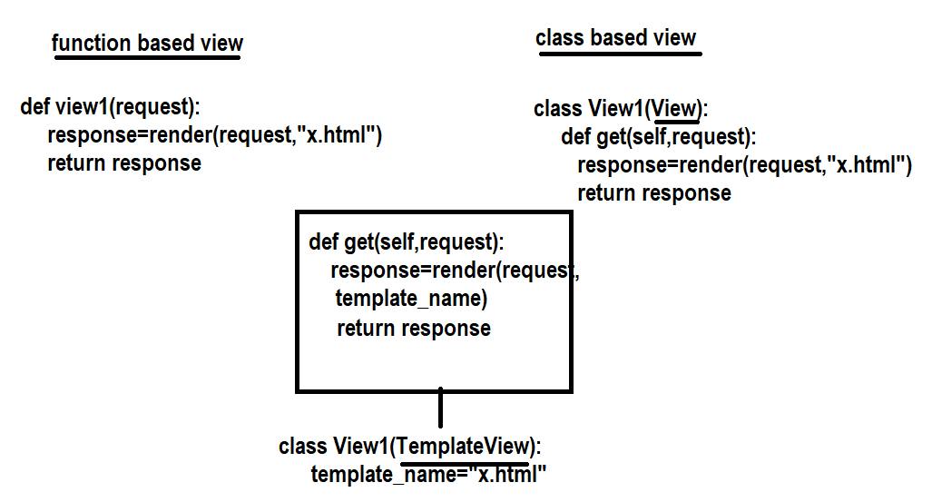

PS D:\Backup\Django9amMar> django-admin startproject project23
PS D:\Backup\Django9amMar> cd project23
PS D:\Backup\Django9amMar\project23> python manage.py startapp app
PS D:\Backup\Django9amMar\project23>

Views.py
from django.shortcuts import render
from django.views.generic import TemplateView
# Create your views here.

class TemplateView1(TemplateView):
template_name="temp1.html"

class TemplateView2(TemplateView):
template_name="temp2.html"
def get_context_data(self, **kwargs):
context=super().get_context_data(**kwargs)
context['name']="naresh"
context['age']=60
return context

temp1.html
<!DOCTYPE html>
<html lang="en">
<head>
<meta charset="UTF-8">
<meta name="viewport" content="width=device-width, initial-scale=1.0">
<title>Document</title>
</head>
<body>
<h1> This is Template1</h1>
</body>
</html>

Temp2.html
<!DOCTYPE html>
<html lang="en">
<head>
<meta charset="UTF-8">
<meta name="viewport" content="width=device-width, initial-scale=1.0">
<title>Document</title>
</head>
<body>
<h2> This is template2</h2>
<h2>{{name}}</h2>
<h2>{{age}}</h2>
</body>
</html>

Urls.py
from django.contrib import admin
from django.urls import path
from app.views import TemplateView1,TemplateView2
urlpatterns = [
path('admin/', admin.site.urls),
path('view1/',TemplateView1.as_view()),
path('view2/',TemplateView2.as_view()),
]

Settings.py
INSTALLED_APPS = [
'django.contrib.admin',
'django.contrib.auth',
'django.contrib.contenttypes',
'django.contrib.sessions',
'django.contrib.messages',
'django.contrib.staticfiles',
'app'
]

TEMPLATES = [
{
'BACKEND': 'django.template.backends.django.DjangoTemplates',
'DIRS': [BASE_DIR/"templates"],

ListView

In Django, a ListView is a built-in generic class-based view used to display a list of objects from a database model
It simplifies common tasks by automatically handling database queries and context preparation

Syntax:
class view-class-name(ListView):
model=model-name
template_name=template path
context_object_name=”query set object name”

default context object name or query set object name is “object_list”
ListView is used for handling get request

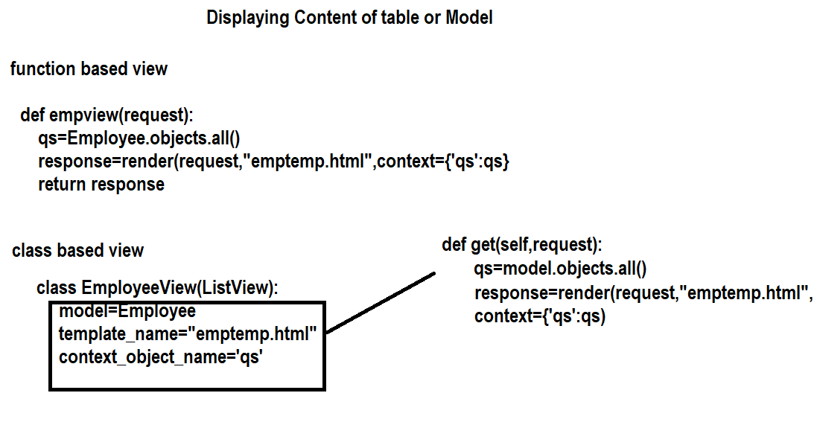

PS C:\Users\Satish Gupta> cd D:\Backup\Django9amMar
PS D:\Backup\Django9amMar> django-admin startproject project24
PS D:\Backup\Django9amMar> cd project24
PS D:\Backup\Django9amMar\project24> python manage.py startapp app
PS D:\Backup\Django9amMar\project24>

